USER SERVICE MANUAL

Notice to Users

Please read this Product Manual carefully before use for proper operation.
Please carefully check whether the parts are complete against this Product Manual before your ride for the sake of safety. Contact your dealer in time in case of any problems.
Please follow the traffic laws. Slow down on rainy or snowy days, on slippery roads. Increase the braking distance for the sake of safety.
The scooter can operate on rainy or snowy days, but it can’t operate in water. When the water reaches middle axle, it may cause rusting or failure of the motor, battery or other parts.
Do not dismantle the scooter on your own. Please contact the after-sales service for replacement or purchase of original parts.
Do not lend your electric scooter to those who can’t operate an E-scooter for the safety of others and for prevention of unnecessary damage to your scooter.
Please keep the Product Manual and the Warranty Card properly.

Precautions

Rider and Passenger
This vehicle is not designed for a ride of more than 2 persons.

Please carefully read this Maintenance Manual.
Warning: Failure to follow the instructions herein may lead to serious casualties.

Caution: Failure to follow the instructions herein may lead to personal injury or damage of parts.
Note: Provide useful information.
This Product Manual should be deemed as a permanent document of your electric scooter. If this scooter is transferred to others, this Product Manual should be handed over to the new owner as well. Without the written consent of the Company, reproduction or reprint of any part of this Product Manual is prohibited.

Safety Notice

Wear a safety hamlet
Using a quality safety hamlet is the priority for protection. Use proper protective goggles as well.

Know your vehicle
Your riding skills and mechanical knowledge is the foundation for safe riding. You are advised to practice your riding on open, quieter roads, and know the mechanical performance and operation methods first.

Know your riding skills
Always ride the scooter within your skill range. Know your riding skills and the operation methods of the scooter so as to prevent accidents.

Notice for Riding on Rainy Days
It should be noted that the braking distance on rainy days should be twice of that on sunny days. Always avoid the roads with paint markers, manhole covers and oil stains to prevent slipping. Pay extra attention when riding through railway crossings, iron fences and bridges. Slow down if road conditions are unclear.

D

Safety Notice

Do not use the high beam light indiscriminately.
Continuous use of the high beam light on urban roads and pedestrian-packed roads may disturb the vision of the drivers and pedestrians and affect normal, safe driving. Do not use the high beam light when the road is well-lighted.

Do not make or receive calls while riding.
Making or receiving calls while riding is one of the main reasons for inattention and will easily cause accidents. Please stop the scooter before you make or receive calls.

Do not change the lane at will.
Changing the lane at will is one of the important reasons for accidents. When you need to change the lane, remember to switch on the Turn Indicator first. Check the scooters approaching from behind and change the lane when it’s safe.

CONTENTS
Notice to Users 1
Precautions 2
Safety Notice 3
Parts Info 6
Operational Guide 8
Battery Use and Maintenance Guide 15
Dos and Don't s in Riding 18
Maintenance and Repair 20
Regular Maintenance Checklist 25
Technical Parameters 31
Maintenance Record 33

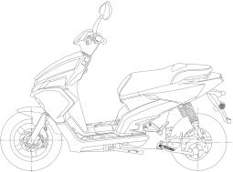
Rear view Mirror
Head Light Turn Indicator
Turn Indicator Taillight

Charging interface

Side Stand

6

Main Stand

Motor

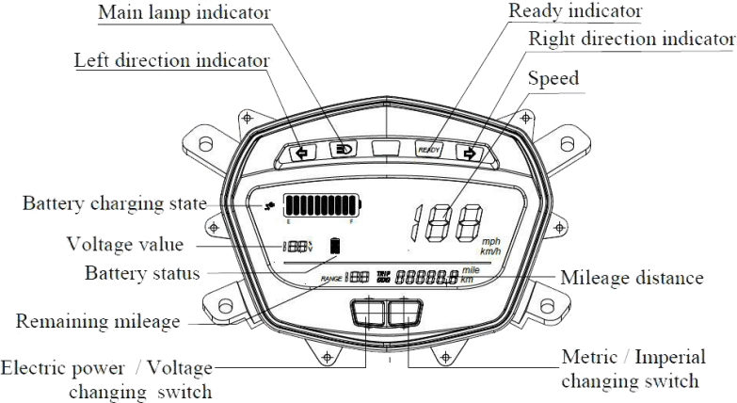

Operational Guide

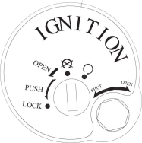
OFF
ON
Open Seat

Open the Lock hole

Lock the Steering Handlebar Lock the Lock hole

Lock hole

Open the seat Open the scooter
Inset the key into the lock hole, press it then turn it to “Lock” to lock the Steering

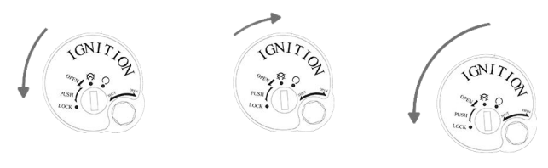
Handlebar.

Operational Guide

Left Combination

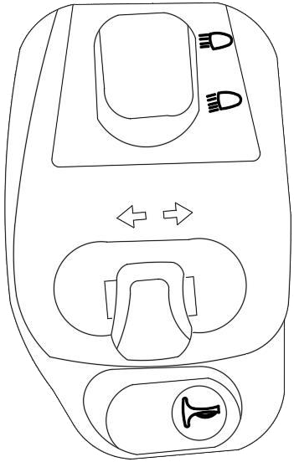
①High Beam Light

②Turn Indicator

③Horn

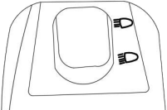
①High/Low Beam light: Press the upper part to turn on the high beam light; press the lower part to turn on the low beam light

High Beam Light

Low Beam Light
Remarks: To signal overtaking, the rider may press and hold the Pass button to enable the High Beam Light and Low Beam Light Interchange Mode. Release the Pass button to return to the Low Beam Light.

Left Combination

①High Beam Light

②Turn Indicator

③Horn

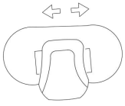
②Turn Indicator: Push the button left to turn on the Left Turn Indicator; push the button right to turn on the Right Turn Indicator. Press the button to reset and the Left/Right Turn.

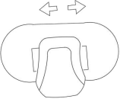
Push the button left/right to turn on the Left/Right

Push the button to center to reset.

Right Combination

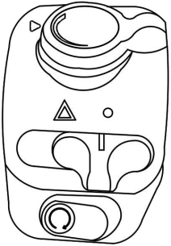
①Drive mode with 3 gears

○2 Hazard Warning

○3 Engine on

Parking
After you reach the destination, turn the key anticlockwise to . Balance the scooter with your right foot. Unfold the side stand with your left foot to park the scooter. Turn the handlebar left to the fullest, press the key downward and turn it anticlockwise to lock.
Locking
The scooter can only be locked when the key is in

Battery Use Environment
The battery is to be used at the ambient temperature range from
-10°C to 45°C.
Do not expose the battery to water, beverages or corrosive liquids to prevent possible leakage, overheat, smoking, fire or explosion.
Do not keep the battery close to heat source, open fire, inflammable and explosive gases and liquids, so as to prevent possible leakage, overheat, smoking, fire or explosion.
Metal objects in the battery compartment may lead to leakage, overheat, smoking, fire or explosion.
In case of undesirable odor, overheat or deformation of the battery, please disuse the battery immediately, keep away from the battery and contact the after-sales service.
Warning: The battery is not a repairable part by the user. In case of battery fault, please contact the after-sales service. Users dismantling the battery may lead to leakage, overheat, smoking, fire or explosion.

Battery Charging Environment

Please charge the battery at the ambient temperature range from 0°C to 35°C. The battery charging time should not exceed 24 hours. Overcharge will shorten the battery life.

Attention: Charging is not available at an ambient temperature below 0°C. Please charge the battery at an ambient temperature over 0°C.

Warning: Using non-original battery chargers may lead to leakage, overheat, smoking, fire or explosion.

Battery Charging Methods

Charging port

Battery housing

①Remove the battery from the scooter.

②Plug the charging plug into the charging socket. When the charging indicator turns from green to red,the scooter is charging. After the charging indicator turns from red to green, charging is saturated.

Attention:
If the battery is not full after charging for over 24 hours, please stop charging and contact the after-sales service.
To maximize the battery life, users are advised to keep the battery
percentage within the range of 20% to 80% as practicably as possible. Please use the accelerator handlebar gently in a normal ride.
Do not keep the battery at an ambient temperature over 40°C so as to prevent irreversible capacity loss of the battery.
At low temperatures, the lithium battery capacity will lose at varying degrees. To be more specific, the usable capacity at -10°C is 70%, that at 0°C 85% and that at 25°C 100%.
The best battery capacity for storage is 50%. Storage of battery less than 10% full or more than 90% full over a long period of time will cause irreversible capacity loss of the battery.
For storage over a long period of time, please keep the battery at an ambient temperature from -20°C to 40°C, and have a charge and a discharge at least once a month so as to minimize battery capacity loss in storage.
Do not keep the battery in places with the risk of falling. That’s
because falling may cause uncontrollable internal damage to the battery and may lead to leakage, overheat, smoking, fire or explosion.

Checks before Riding
Please make the following checks before you ride the scooter. Do not overlook the importance of these checks. Complete them one by one before riding.
Check Key Points
Description
1) Steadiness
Steering 2) Flexible steering
Handlebar 3) No axial displacement or loosening
- Braking handlebar has a 5 to 9mm idle travel.

Braking

Tyre Battery Lights
Horn
- The air pressure range of the front tyre is 20 to 25psi; the air pressure range of the rear tyre is 26 to 32psi.
- Normal air pressure
- Proper tyre tread depth
- No cracks or openings
Adequate for planned distance to travel
Check all the lights—High beam light, low beam light, brake light, turn indicator, etc. to ensure that they can work.
Check whether the horn can work.

Braking Precautions
Always balance the scooter before braking.
If the tyres are locked resulting from excessive braking force, loosen the grip on the braking handlebar and the tyre will be working again and the scooter will be stabilized. If the front tyre is locked, the scooter will lose the ability to steer.
Try to maintain a 1:1 ratio of front and back braking force on slippery roads.
Attention:
The inexperienced drivers tend to use the rear brake only, which will accelerate the wear of the brake and result in a long stopping distance.

Warning:
Using the front brake or rear brake only is dangerous because of possible grip or control loss. Pay extra attention and use the brakes gently when riding on damp, slippery roads and around the corners.
Riders slamming on the brakes will be exposed to great danger.

Maintenance and Repair
To extend the service life of the scooter and for a safe, comfortable ride, users are advised to have the scooter checked and maintained on a regular basis. A scooter not used for a long period of time also needs to be checked on a regular basis.

Regular Maintenance
The first maintenance should be conducted one month after purchase or after a travelling distance of 500km. An overall check and maintenance should be conducted in after-sales service every 6 months or 3000km thereafter. Regular check and maintenance are aimed for the safety of the scooter and the rider.
Attention:
If the scooter is frequently subject to such use conditions as overload, high-speed, bumpy roads, uphill and downhill riding, the maintenance cycle should be shortened.
Original parts made from quality materials and rigorously tested are recommended for guaranteed quality and service life, and for best scooter conditions and riding safety. Parts are under normal warranty.

Daily Maintenance
If abnormalities are found during checks and the scooter needs cleaning, maintenance or parts replacement, users may have checks and maintenance in reference to the Home Repair Instructions or send the scooter to the dealer's for checks and maintenance.
Warning:
If incapable of repair or adjustment on his/her own, the scooter owner is advised to send the scooter to the dealer’s for maintenance and adjustment for the sake of safety.
Always choose a smooth surface road for repair and adjustment and unfold the central stand before repair and adjustment. If it’s necessary to repair the scooter during a ride, please mind the traffic.

Brake Adjustment

If abnormalities are found during checks and the scooter needs cleaning, maintenance or parts replacement, users may have checks and maintenance in reference to the Home Repair Instructions or send the scooter to the dealer’s for checks and maintenance.

Scooter Washing
Please use a hose and wash the scooter with running water And neutral detergent. Wipe the scooter with a piece of soft cloth after washing. Do not use a piece of dry cloth to prevent scratching.

Warning:
Never use a pressure washer to wash the scooter.
Do not wash the two sides, the rear and the inner of the battery compartment with a pressure washer. Do not flush the upper side cover on the rear wheel where the charger, controller and other parts are installed, so as to prevent damage by water. If the scooter falls to the ground by accident, the AC high-voltage charger may be wetted. In that case, do not charge before the charger dries to prevent an electric shock. Repair in the service center is recommended. Do not use it before it’s properly checked.

Storage Method
Short-term Storage:
  - Keep the scooter on flat, steady surfaces in well-ventilated and dry places;
  - Charge the battery to 50% full before storage to ensure the service life of the battery;
  - Avoid exposure to the sun and rain as practicably as possible to reduce damage or aging of the parts;
  - Charge the battery to 100% full for long-term storage;

Maintenance and Repair

  - If the scooters installed with batteries are stored indoor or in safe places like showrooms and storerooms or packed for short-
distance transportation in transport vehicles, Connection of power cord
and lithium battery should be disconnected to prevent potential electrical fault.

Long-term Storage:

- Remember to have a charge and a discharge at least every two months for long-term storage, and charge the battery to 50% full before storage to ensure the service life of the battery;
- Please charge the battery to 100% full before use after long- term storage;
- Check all the parts carefully and make sure that there is no abnormality before taking a ride on the road. In case of any abnormality, send the scooter to the dealer’s for maintenance or repair.

Vehicle and brake inspection
1. Front wheel brake
- Check the brake fluid level through the sight glass at the center of the brake lever.
- Place the vehicle in the center position of the main stand and rotating handle on a level ground
- 2. Check for damage and scratches on the disc brake, and check for scratches and damages on the brake disc.
- When wear is limited, please follow the recommended maintenance interval, so replace the brake discs and wear pads.
- Check for any leakage of brake fluid between the brake line and brake cylinder.

Electrical inspection

Charge the voltage check
Battery charging circuit
Charge current warning: Before checking, make sure that the battery is working properly
1. Check of the turning indication system
The turning indicator circuit is controlled by the power control unit, if not working, there must
To do the following operations:
Check whether the power-off switch is normal
Check that the light bulb is working
Check the function of the turning signal switch

Common faults and troubleshooting methods for electric vehicles
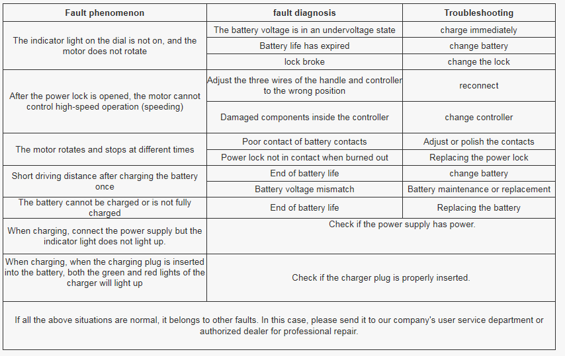

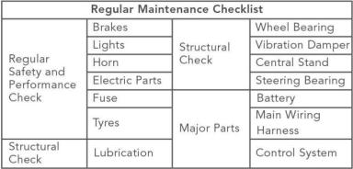

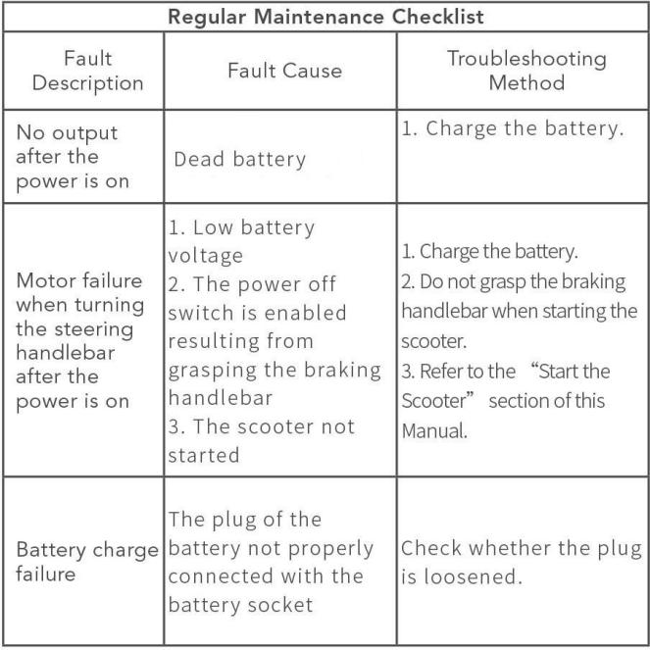

28
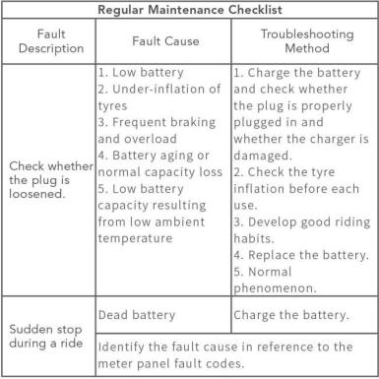

29

Key Features
Product Weight | 88kg | Grade ability | Dynamic: 15°
Rated Voltage | 72V | Maximum Designed  Speed | 85km/h
Maximum Load | 265 | Braking Distance | ≤4.5m  (30km/h)
Designed Capacity |  | 2 Person

30

Frame
Front Damper | Sleeve and oil damping
Rear Damper | Spring and oil damping
Front Tyre Specifications | 120/70-12
Rear Tyre Specifications | 120/70-12
Front Brake Mode | Manual Disc Brake
Rear Brake Mode | Manual Disc Brake
Maximum Ground Clearance | 165mm
Seat Height | 800mm
Battery System
Voltage | 72V
Capacity | 30AH
Standard Charging Current | 8A
Maximum Discharging Current | 70A

Power System
Motor | Permanent-magnet Brush-less Motor
Motor Control Mode | FOC
Motor Maximum Power | 4000 W
Controller Maximum Current | 100A
Electrical System
Headlight | 12 V
Turn Indicator | 12 V
Taillight | 12 V
Brake light | 12 V
Meter Panel | 12 V
Central Control Unit | 12 V

Date | Fault Description | Fault Cause and Troubleshooting  Method | Service Station | Serviceman | Remarks

Date | Fault Description | Fault Cause and Troubleshooting  Method | Service Station | Serviceman | Remarks

